Work Experience Packet

Paid or unpaid work experiences are sometimes called Internships. Statistically, 3 out of 4 internships turn into jobs. The job offer may not come from the company or organization where you did your work experience, but as you develop contacts and skills helping you to advance your employment.

Tips for being successful:
- View this experience the same way you would a regular job, such as arriving early, working hard, and dressing appropriately.
- Put everything in place with your personal life so you are ready to go to work.
- If you have children, make sure you have arranged a babysitter or daycare.
- Do you have your transportation figures out? It is reliable?
- You may be expected to take a drug test, plan accordingly.
- Make sure your resume looks good and is current.
- Prepare your interview outfit.
- If you need help with anything, ask your Career Mentor or work site supervisor.
- Consider all job offers; remember you are new to this career.
- If you really want employment you will need to be diligent and work at it.

A Worksite Agreement will be put in place to guide the learning experience. You will be working closely with your Career Mentor to structure and guide this experience. The agreement helps the employer, participant, and Career Mentor understand the expectations of the work experience.

Questions you may want to ask:
1. What time do you report to work?
2. How many hours a day do you work?
3. What would your responsibilities be?
4. To whom would you report?
5. Does the organization have a mission statement? If so, what is it?

The End of Your Work Experience

- A formal thank you card thanking the individuals and the company leadership you worked with. This shows a high degree of professionalism.

- Take time for a personal thank you to the people who taught you and guided your learning there. Request letters of recommendation from supervisors who know your work well enough to give specific comments and recommendation. Ask them if they will also be a reference for your job.

- You are not eligible for unemployment once your work experience ends as you were not hired as an employee for the company you worked at.

Timesheet Completion Procedure

- Your name, Mentor’s name, and phone # must be filled in on each timesheet.

- Your timesheet must be filled in daily.

- If you work more than 6 hours, you must take an UNPAID ½ hour lunch break.

- If you work more than 4 hours, you are required to take a 10 minute break – paid.

- No one is to work over an 8 hour period. CA law does not allow more than 8 hours a day without overtime pay. Career Institute does not pay for overtime.

- It is your responsibility to calculate your hours. Please double-check for accuracy.

- BOTH You AND your employer must both sign and date the timesheet.

- For the dates of when your timesheet must be submitted, please refer to the website at www.cinow.org for the payroll schedule.

- Submit your timesheet by email to: payroll.cinow@gmail.com by the timesheet due date on the payroll schedule.

- Hours that are not submitted by the Timesheet Due Date, will need to have approval for payment. Therefore, payment will be delayed. Time claimed 30 days past due date, will not be eligible for payment”.

- You will be paid current minimum wage hourly.

- You will be paid on a Cash Card. This card should have been given to you after you were approved for the program.

How to Use Your Global Cash Card

- You will receive your payroll funds on a global cash card. You must first activate your card at www.globalcashcard.com or by calling (866) 395-9200 and following the prompts. You will be asked to choose a PIN. Once completed, you will be able to access your funds.
- Transaction fees—your card may be used at ATMs or Point of Sale terminals.
- When making purchases, select “Credit” at the PIN pad… there is no fee.
- Always ask for “Cash Back” at grocery stores when using your PIN. The “Cash Back” is free of any fee.
- Always know your balance so you avoid decline and over limit fees.
- Check your balance online or on the telephone…it’s free!
- First ATM transaction (Allpoint Network) per week has no fee.
- Point of Sale purchases have no fees.
- Additional ATM transactions (Allpoint Network) per week $1.75
- ATM Withdrawals (Out of Network) $1.75
- ATM Balance Inquiry $1.00
- ATM Decline $1.00
- Inactivity (After 90 days) $3.00
- Online Bill pay has no charge.

- Using Your Card: The Card is a prepaid card. The Card allows you to access funds loaded or deposited to your Card account by you or on your on your behalf. Your Card account is not a checking or savings account and is not connected in any way to any other account you may have. The Card is not a gift card. The card is not a credit card. You will not receive any interest from the funds in your Card account. The funds in your Card account will be FDIC insured if your card is registered. Your funds will never expire, regardless of the expiration date on the front of your card. You may register your card by going to www.globalcashcard.com.

- Once your card has been activated you will receive a second card in the mail. This second card will have your name printed on the card. Both cards are valid and may be used. It is best to use one card for your everyday transactions, and keep the other card in a safe place as a backup.

- Personal Identification Number (PIN): You have the ability to request a Personalized Identification Number (PIN). You may use your card to obtain cash from any ATM machine, or at any point-of-sale (POS) device which requires entry of a PIN, that bears the VISA, Interlink, Plus and Maestro brand. All ATM transactions are treated as cash withdrawal transactions. You should not write or keep your PIN with your Card. If you believe anyone has gained unauthorized access to your PIN, you should advise us immediately.

- Card Account Access: You may use your Card to: (1) withdraw cash from your Card account, (2) make deposits to your card account, (3) purchase or lease goods or services wherever your Card is honored so long as you do not exceed the value available in your Card account, and (4) pay bills directly [by telephone] from your Card account in the amount and on the days you request.
You may use your Card to access cash at any ATM. Deposits to your Card account are not permitted at our ATM terminals. You may not use your Card for any illegal transactions, in casinos, or any gambling activity.
- Your ATM withdrawal limit is ($500.00) per transaction (If ATM allows it).
- You may not exceed five (5) ATM transactions in a 24 hour period.
You are responsible for all transactions initiated by the use of your Card. If you do not have enough funds available in your Card account, you can instruct the merchant to charge a part of the purchase to the Card and pay the remaining amount with cash or another card. These are called “split transactions.” Some merchants do not allow cardholders to conduct split transactions. Some merchants will only allow you to do a split transaction if you pay the remaining amount in cash. If you use your Card number without presenting your Card (such as for a mail order or telephone purchase), the legal effect will be the same as if you used the Card itself. You are not allowed to exceed the available amount in your card account through an individual transaction or a series of transactions. If a transaction exceeds the balance of the funds in your Card account, you will owe Global Cash Card for any negative balance. Global Cash Card can cancel and close your Card account should you create one or more negative balances with your Card.

- Receipts: You should get a receipt at the time you make a transaction or obtain cash using your Card. You should retain your receipt to verify your transactions.

- Obtaining Card Account Information: You may obtain information about the amount of money you have remaining in your Card account by calling (866)-395-9200. This information, along with a 60-day history of account transactions, is also available on-line at www.globalcashcard.com.

- Lost or Stolen Cards; Unauthorized Transactions. If you believe your Card or PIN has been lost or stolen, call: (866)-395-9200 or write to: 7 Corporate Park Suite 260, Irvine, CA, 92606. You should also call the number or write to the address listed above if you believe a transaction has been made using the information from your Card or PIN without your permission. Tell us AT ONCE if you believe your Card has been lost, stolen or used to make unauthorized transactions. Your liability for unauthorized transactions that take place on the “MasterCard” system is zero dollars ($0).

- If you have any questions, call Customer Service at (866)-395-9200.

Copies of your pay statements may be printed from the Payroll Website at yourpayrollhr.com/ta/CII02.login (capital ‘C’ capital ‘I’ capital ‘I’ zero two.login)

The preferred internet browser for Workforce Link is Mozilla Firefox; although Google Chrome and Safari will work as well. Internet Explorer is not recommended as the software will not allow you to login in some versions.

- Go to yourpayrollhr.com/ta/CII02.login
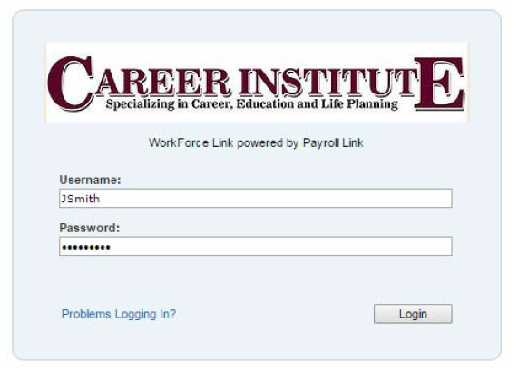
- Your user name will be your first initial last name (ie John Smith = JSmith) and your password will be your social security number (no dashes: 123456789)

- You will immediately be prompted to change your password. Your new password must be at least 7 characters long.
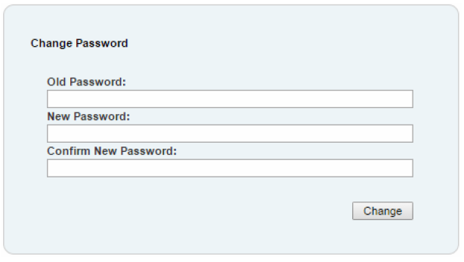

Once you are logged onto the Payroll website, you may view your pay statements.

- Go to My Account > My Pay statements

- Please note the “Pay Date” in the top right corner will default to show you “Calendar Range: Last Month and future.” You can change this to fit the range of pay statements you need to see.

- To view a statement click

- This will open the pay statement in a preview pane:
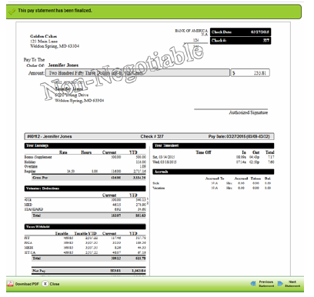

- If you wish to print your pay statement, click in the lower left corner. This will open a new window and you can then print the pay statement. If you do not choose to download the pdf, and print from the preview pane, it will not print correctly and the top and bottom of the pay statement will be cut off.

- If you are locked out of the payroll website or cannot remember your password, please call the Career Institute office at: (909) 481-0270. A payroll clerk will unlock your account and reset your password to your social security number.

ACCIDENT / INJURY AUTHORIZATION FORM TO CONSENT TO THE MEDICAL / SURGICAL TREATMENT OF A MINOR

I, the undersigned parent and/or legal guardian of , whose date of birth is , do hereby authorize medical and/or surgical treatment by a State of California licensed medical doctor (M.D.), and or a State of California licensed hospital and/or a licensed hospital emergency room and/or a private practice office operated by a State of California licensed medical doctor (M.D.), duly certified and licensed and/or their representatives as agent(s) for the undersigned to consent to any X-ray, laboratory, anesthetics, medical or surgical diagnosis, or treatment and hospital care which is deemed advisable by, and is to be rendered under the general or special supervision of a licensed medical doctor (M.D.) as per the provisions of the Medical Practice Act and who is on the staff of the accredited hospital, whether such diagnosis or treatment is rendered at the office of the treating physician or at any accredited hospital.

It is understood that this authorization is given in advance of any specific diagnosis, treatment, or hospital care being required, but is given to provide authority, consent, and power on the part of our aforesaid agent(s) to give specific consent to any and all such diagnosis, treatment, or hospital care which the aforementioned physician in the exercise of his medical and surgical judgment may deem advisable pursuant to the provisions of §25.8 of the Civil Code of California.
In addition, you are authorized to release and/or to receive any and all medical records and/or related medical information pertaining to and/or aiding in the treatment rendered the minor named above with regard to the minor/minor's industrial accident/injury.
``````````````````````````````````````````````````````````````````````````````
Family Doctor: Phone #:
Parent/Legal Guardian's Signature: Date:
Signature of Witness: ______________________
18 years old. Emergency Notification for Information Only.
IN CASE OF EMERGENCY, PLEASE NOTIFY:
Name: Relationship:
Complete Address:
Telephone #: Email Address: ___________________________________
Please list personal physical information that hospital or physician should be aware of in case of illness or injury (i.e., diabetic, drug reactions, heart condition, drugs/medications currently taking, allergies, etc.).
______________________________________________________________________________________
______________________________________________________________________________________
Workers Compensation & Safety

Safety
It is important that you use good judgment while at your training site to avoid personal injuries. Do not operate any equipment or machinery without your Training Site Supervisor’s permission and instructions. Follow all safety procedures recommended by your Training Site Supervisor and avoid carelessness at all times.

Workers Compensation
Our insurance coverage will pay for your doctor visit if you are injured on the job, but NOT the time you are out of work if you are injured on the job. You are only paid for the hours that you are at your training site.

Remember that it is against the law to say you are hurt when you are not. There are very serious fines and punishments for falsifying an on the job injury claim.

Report all injuries immediately to your Training Site Supervisor and Career Mentor

If you are injured on the job:

- If it is an emergency, have your Training Site Supervisor immediately take you to the nearest medical facility.
- If it is not an emergency, report your injury to your Training Site Supervisor and contact your Career Mentor.
- You will have to sign your written statement regarding how you became injured.
- Even if it is a small injury and you don’t think it is important enough to bother your Training Site Supervisor with, please still inform them.

Participant Name: __________________________________
Social Security Number: __________________ Date: __________

I understand that I may not apply for Unemployment Insurance
I understand that I am may not apply for Unemployment Insurance once I have completed my paid Training Experience.

This is because I am participating in a paid Training Experience Program funded by the Workforce Development Department who receives federal dollars from the Workforce Investment Opportunity Act (WIOA). I am doing a work experience to gain work maturity and experience in the job market. I have not been hired as an employee.

Please use section code 634.5, section E1 for determination purposes. (e) By an individual receiving work relief or work training as part of an unemployment work relief or work training program assisted or financed in whole or in part by any of the following:
(1) A federal agency.

Participant Signature: ______________________________________

Motor Vehicle Directive
I understand that as a participant on a work experience of the Career Institute, that I may not drive a motor vehicle, either company or personal, while on my work experience. The Career Institute does not carry insurance for participants while on a work experience, and will therefore not be held liable. Any questions should be directed to your Career Mentor.

Participant Signature: ______________________________________

Worksite Monitoring

Participant: __________________ Mentor: _______________

Worksite: ___________________________________________

Supervisor: __________________________ Date: __________

Employability Factors  & Work Habits | Rating &Comments  5 - Superior 2 - Needs Improvement  4 - Very Good 1 - Unsatisfactory  3 – Satisfactory
Maintains a positive Attitude
Positive customer service skills
Attendance – Reports to work on time
Attendance - Returns from breaks on time
Appearance - good grooming & hygiene habits
Dresses appropriately for the job
Shows initiative & Ambition
Accountability – has ethical behavior
Completes tasks in timely manner
Follows direction
Works independently
Quality of work
Accepts authority of supervisor
Works well with coworkers
Respects the rights of others
Follows company rules and regulations
Appreciation – has attitude of gratitude
Accepts guidance or correction well
Work Site Agreement at location

___________________________ ______________________ ________________________
Career Mentor Signature Supervisor Signature Participant Signature

